C:\Users\Inger\AppData\Local\Microsoft\Windows\Temporary Internet Files\Content.IE5\F77MW0Y9\MC900304573[1].wmf

scharen

C:\Users\Inger\AppData\Local\Microsoft\Windows\Temporary Internet Files\Content.IE5\0XM8PV02\MC900312062[1].wmf

gummen

C:\Users\Inger\AppData\Local\Microsoft\Windows\Temporary Internet Files\Content.IE5\0XM8PV02\MC900290924[1].wmf

linialen

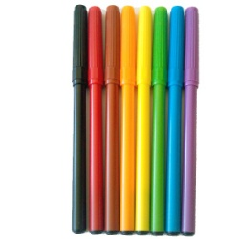

stiften

C:\Users\Inger\AppData\Local\Microsoft\Windows\Temporary Internet Files\Content.IE5\F77MW0Y9\MC900295069[1].wmf

schrijf

potloden

C:\Users\Inger\AppData\Local\Microsoft\Windows\Temporary Internet Files\Content.IE5\ZIGAP9CA\MC900412400[1].wmf

kleurpotloden

C:\Users\Inger\AppData\Local\Microsoft\Windows\Temporary Internet Files\Content.IE5\ZIGAP9CA\MC900412400[1].wmf

kleurpotloden

C:\Users\Inger\AppData\Local\Microsoft\Windows\Temporary Internet Files\Content.IE5\ZIGAP9CA\MC900297995[1].wmf

kranten

C:\Users\Inger\AppData\Local\Microsoft\Windows\Temporary Internet Files\Content.IE5\GAA4HCUL\MC900297141[1].wmf

wit papier

C:\Users\Inger\AppData\Local\Microsoft\Windows\Temporary Internet Files\Content.IE5\F77MW0Y9\MC900290030[1].wmf

wc-papier

C:\Users\Inger\AppData\Local\Microsoft\Windows\Temporary Internet Files\Content.IE5\0XM8PV02\MC900239307[1].wmf

tissues

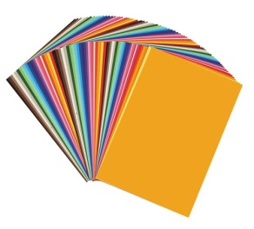

gekleurd

papier

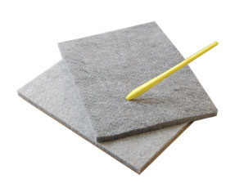

prikpennen

prikmatten

C:\Users\Inger\AppData\Local\Microsoft\Windows\Temporary Internet Files\Content.IE5\0XM8PV02\MC900198594[1].wmf

juf

C:\Users\Inger\AppData\Local\Microsoft\Windows\Temporary Internet Files\Content.IE5\0XM8PV02\MC900198594[1].wmf

juf

C:\Users\Inger\AppData\Local\Microsoft\Windows\Temporary Internet Files\Content.IE5\GAA4HCUL\MC900290272[1].wmf

papier

C:\Users\Inger\AppData\Local\Microsoft\Windows\Temporary Internet Files\Content.IE5\0XM8PV02\MC900199731[1].wmf

lijntjes

papier



stoffer

en blik

C:\Users\Inger\AppData\Local\Microsoft\Windows\Temporary Internet Files\Content.IE5\0XM8PV02\MC900198594[1].wmf

juf

C:\Users\Inger\AppData\Local\Microsoft\Windows\Temporary Internet Files\Content.IE5\0XM8PV02\MC900198594[1].wmf

juf

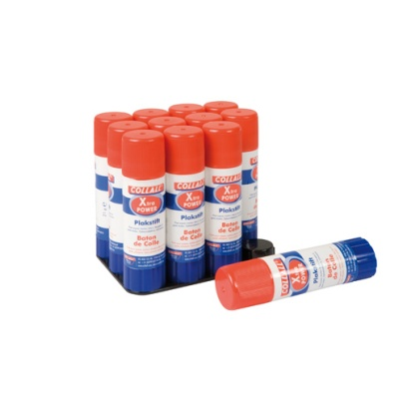

lijmstiften

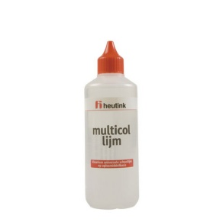

sterke lijm

leeswijzers

tafeldiploma’s

dagritmekaarten

woordenschat

C:\Users\Inger\AppData\Local\Microsoft\Windows\Temporary Internet Files\Content.IE5\0XM8PV02\MC900198594[1].wmf

juf

C:\Users\Inger\AppData\Local\Microsoft\Windows\Temporary Internet Files\Content.IE5\0XM8PV02\MC900198594[1].wmf

juf

C:\Users\Inger\AppData\Local\Microsoft\Windows\Temporary Internet Files\Content.IE5\0XM8PV02\MC900198594[1].wmf

juf

C:\Users\Inger\AppData\Local\Microsoft\Windows\Temporary Internet Files\Content.IE5\0XM8PV02\MC900198594[1].wmf

juf

C:\Users\Inger\AppData\Local\Microsoft\Windows\Temporary Internet Files\Content.IE5\ZIGAP9CA\MC900295063[1].wmf

puntenslijpers

spellingkaarten

C:\Users\Inger\AppData\Local\Microsoft\Windows\Temporary Internet Files\Content.IE5\GAA4HCUL\MC900279226[1].wmf

meester

C:\Users\Inger\AppData\Local\Microsoft\Windows\Temporary Internet Files\Content.IE5\GAA4HCUL\MC900279226[1].wmf

meester

C:\Users\Inger\AppData\Local\Microsoft\Windows\Temporary Internet Files\Content.IE5\GAA4HCUL\MC900279226[1].wmf

meester

C:\Users\Inger\AppData\Local\Microsoft\Windows\Temporary Internet Files\Content.IE5\GAA4HCUL\MC900279226[1].wmf

meester

C:\Users\Inger\AppData\Local\Microsoft\Windows\Temporary Internet Files\Content.IE5\GAA4HCUL\MC900279226[1].wmf

meester

C:\Users\Inger\AppData\Local\Microsoft\Windows\Temporary Internet Files\Content.IE5\GAA4HCUL\MC900279226[1].wmf

meester